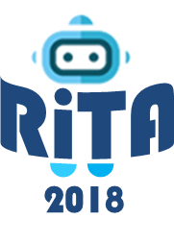
The 6th International Conference on
Robot Intelligence Technology and Applications
16 – 18 December 2018
Kuala Lumpur, Malaysia
http://2018.icrita.org

Sponsorship & Exhibition Opportunities

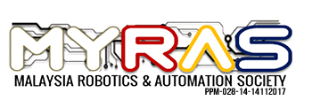
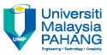
Sponsored by

RiTA2018 Synopsis

Meeting: The 6th International Conference on Robot Intelligence Technology and Applications (RiTA2018)

Date: 16 – 18 December 2018

Venue: Pullman Putrajaya Lakeside, Malaysia

Website: http://2018.icrita.org

No of Expected participants: About 200 scientists from 20 countries

Highlighting Programs
- Workshops and Tutorials
- Welcome Reception
- Plenary talks / Invited talks / Special Talk
- Oral Presentation Sessions
- Poster Presentation Sessions
Conference Banquet

Conference Scope

• Cognitive Intelligence • Social Intelligence • Collective Intelligence • Behavioral Intelligence
• Ambient Intelligence • Genetic Intelligence • Artificial Intelligence • Applications

Conference Organizers
Honorary General Chair: Jong-Hwan Kim, KAIST, Korea
General Chairs: Zahari bin Taha, Universiti Malaysia Pahang, Malaysia
Hyun Myung, KAIST, Korea
Program Chairs: Dato' Sri Daing Nasir Ibrahim, UMP, Malaysia
Rizalman Mamat, UMP, Malaysia
Han-Lim Choi, KAIST, Korea
Organizing Chairs: Ahmad Shahrizan Abdul Ghani, UMP, Malaysia
Muhammad Aizzat Zakaria, UMP, Malaysia
Ahmad Fakhri Ab. Nasir, UMP, Malaysia
Junmo Kim, KAIST, Korea
Weiliang Xu, University of Auckland, New Zealand
Eric T. Matson, Purdue University, USA
Jun Jo, Griffith University, Australia
Fakhri Karray, University of Waterloo, Canada

Sponsorship Opportunities & Benefits
Full Set of Sponsorship Benefits
The organizer offers you five levels of full set of sponsorship including Package 1, 2, 3 4 and 5. The benefits of each full set are as follows;

Sponsorship Application Form
- Company Information
Company/Organization
Address:
City: Zip: Country:
Contact Person: Position or Title:
Phone: Mobile:
E-mail: Website:
Describe company or products:
* Attach your company logo to this complete form.
- Sponsorship Interest
Full Set of Sponsorship Benefits Put an x on upon your choice.
Sponsor Level | US Dollars | Payment Date
Package 1 | $1500 and above
Package 2 | $1000 - $1499
Package 3 | $500 - $999
Package 4 | $250 - $499
Package 5 | $249 and below
Other Item, if any:
_______________________________________________________________________________
- Payment Method
Payment must be made by bank wire only. Currency is available in US Dollars.
Bank Information:
▪ Bank Name: WOORI BANK
▪ Account No: 1005-601-320226
▪ Recipient: Korea Robotics Society
▪ Bank Address: 22 Tehranro 7-gil, Gangnam-gu, Seoul 06130, Korea
▪ ABA No: HVBKKRSE
- Signature

Contributor Title Date

Please return this complete application with your proof of payment to RiTA 2018 secretariat below;
Phone: +609-4246358 Email: rita@icrita.org / info@icrita2018.org http://2018.icrita.org

